**(Module 4)= Working with Database using SQL**

**Assignment=**

1. **Statement to create the Contact table**

CREATE TABLE Contact (

ContactID INT PRIMARY KEY,

CompanyID INT,

FirstName VARCHAR(45),

LastName VARCHAR(45),

Street VARCHAR(45),

City VARCHAR(45),

State VARCHAR(2),

Zip VARCHAR(10),

IsMain BOOLEAN,

Email VARCHAR(45),

Phone VARCHAR(12),

FOREIGN KEY (CompanyID) REFERENCES Company(CompanyID)

);

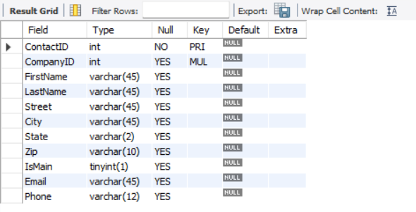

1. **Statement to create the Employee table**

CREATE TABLE Employee (

EmployeeID INT PRIMARY KEY,

FirstName VARCHAR(45),

LastName VARCHAR(45),

Salary DECIMAL(10,2),

HireDate DATE,

JobTitle VARCHAR(25),

Email VARCHAR(45),

Phone VARCHAR(12)

);



1. **Statement to create the ContactEmployee table**

CREATE TABLE ContactEmployee (

ContactEmployeeID INT PRIMARY KEY,

ContactID INT,

EmployeeID INT,

ContactDate DATE,

Description VARCHAR(100),

FOREIGN KEY (ContactID) REFERENCES Contact(ContactID),

FOREIGN KEY (EmployeeID) REFERENCES Employee(EmployeeID)

);

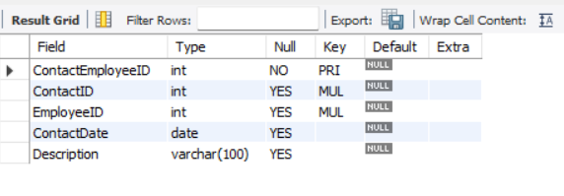

**4) In the Employee table, the statement that changes Lesley Bland’s phone number to 215-555-8800**

update employee

set phone ='2155558800'

where firstname ='lesley' and lastname ='bland';

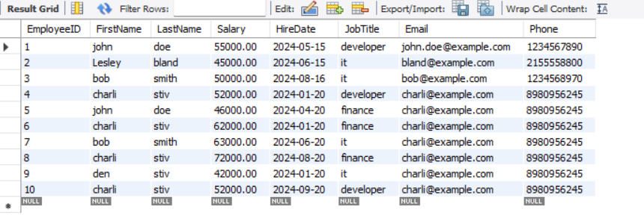

**5)In the Company table, the statement that changes the name of “Urban Outfitters, Inc.” to “Urban Outfitters” .**

update company

set companyname ='urban outfitters'

where companyname ='urban outfitters,inc';

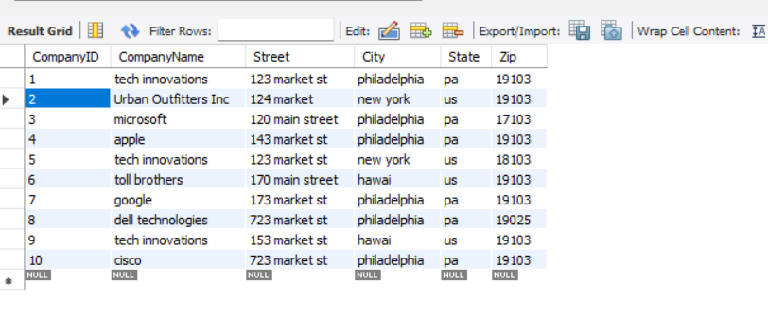

**6) In ContactEmployee table, the statement that removes Dianne Connor’s contact event with Jack Lee (one statement).**

with Emp_name as(

select

c.contactEmployeeId,c.ContactId,e.firstname,e.lastname

from employee e

join contactemployee c

on e.employeeid = c.employeeid

where Firstname = "Diana" and lastname = "Corner"

)

delete et

from contact et

join Emp_name en

on et.contactid = en.contactid

where en.firstname = "Diana" and et.firstname = "Jack";

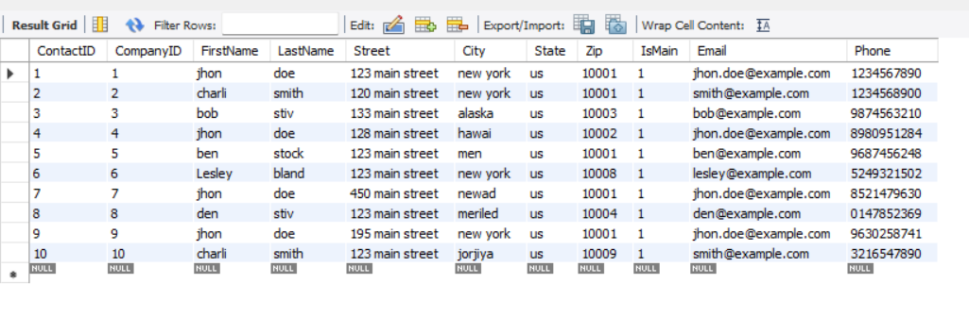

**7) Write the SQL SELECT query that displays the names of the employees that have contacted Toll Brothers (one statement). Run the SQL SELECT query in MySQL Workbench. Copy the results below as well.**

select distinct e.FirstName, e. LastName

from employee e

join contactemployee ce on e.employeeid = ce.employeeid

join contact c on ce.contactid = c.contactid

join company co on c.CompanyID = co.CompanyID

where co.CompanyName ='toll brothers';



